CIVIC SOLIDARITY PLATFORM
STATEMENT ON THE VERDICT AGAINST PUSSY RIOT
22 August 2012

We, the undersigned members of the Civic Solidarity Platform, call on the Russian appellate court, upon the filing of an appeal, to uphold Russia’s international obligations with regard to respect for freedom of expression and quash the criminal convictions against Nadezhda Tolokonnikova, Maria Alyokhina and Yekaterina Samutsevich of the music band Pussy Riot.

On Friday 17 August 2012, the three were sentenced to two years in prison after being convicted of hooliganism motivated by religious hatred under Article 213-2 of the Criminal Code of the Russian Federation. The charges relate to a protest which the group staged in Moscow’s main Russian Orthodox cathedral on 21 February 2012 during which they performed their song Virgin Mary, Drive Putin Away. An edited version of the performance was later uploaded to YouTube.
We, the undersigned organizations, consider the conviction of the three women for their peaceful, if controversial and, in the views of some, offensive protest action, to be wrongful and excessive. In this case, Russian criminal law was misused to stifle freedom of expression as protected by international human rights law.
The Pussy Riot trial is part of a crackdown on freedom of expression since Vladimir Putin returned to the Russian presidency in May 2012. The sentencing of Pussy Riot is emblematic of the Russian government's increasing intolerance of dissent. In June 2012 the Kremlin significantly increased fines for violating the rules on holding peaceful assemblies and, at the same time, toughened these rules to make it more difficult to even hold public protests. The Russian government passed a law that gives authorities the power to order what they consider "extremist" content to be removed from Russian websites. Many fear that this law will be used to crack down on dissent and shut down anti-Putin websites. Russia’s State Duma also adopted a bill that requires many non-governmental organizations, mostly advocacy groups, which receive donations from outside Russia, to register as "foreign agents."
In their closing statements at their trial, Tolokonnikova, Alyokhina, Samutsevich and their lawyers delivered devastating critiques of the state of justice and civic freedoms in Russia. Yekaterina Samutsevich stated: “The whole world now sees that the criminal case against us has been fabricated. The system cannot conceal the repressive nature of this trial. Once again, the world sees Russia differently from the way Putin tries to present it at his daily international meetings”.

Following the trial, which has drawn unprecedented international attention, Russian police rounded up pro-Pussy Riot protesters, including former world chess champion Garry Kasparov and the leftist opposition group leader Sergei Udaltsov.
The OSCE Representative on Freedom of the Media, Dunja Mijatović, expressed concern over the tendency towards curbing freedom of expression, stating that: “Charges of hooliganism and religious hatred should not be used to curb freedom of expression. Speech no matter how provocative, satirical or sensitive should not be restricted or suppressed and under no circumstances should it lead to imprisonment.”
Secretary General of the Council of Europe, Thorbjørn Jagland, also expressed his profound disappointment at the verdict: “The sentence against the Pussy Riot group, as well as the length and conditions of their pre-trial detention seem harsh in relation to the nature of the offence committed in a secular state, member of the Council of Europe and party to the European Convention on Human Rights”.
As a State Party to the European Convention on Human Rights (ECHR) Russia has undertaken legal obligations to uphold the rights to freedom of assembly and expression and to guarantee the enjoyment of those rights without discrimination.
We call upon the authorities of the Russian Federation to put an end to the harassment of activists and to ensure that the fundamental right to freedom of expression is upheld and that no one is imprisoned for peacefully expressing their political views.

 Article 19

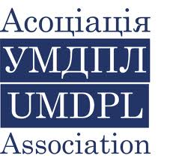 Association of Ukrainian monitors on Human Rights conduct in Law Enforcement (Association UMDPL) (Ukraine)
 Belarusian Helsinki Committee

 Belarusian Human Rights House in exile, Vilnius
 Bulgarian Helsinki Committee

 Centre for Civil Liberties (Ukraine)

 Center for National and International Studies (Azerbaijan)

 Centre for the Development of Democracy and Human Rights (Russia)

 Crude Accountability

 Eurasia Justice Initiative (USA)

Freedom Files Freedom Files (Russia)

 Georgian Young Lawyers’ Association

 Golos Svobody (Kyrgyzstan)

 Helsinki Citizen’s Assembly – Vanadzor (Armenia)
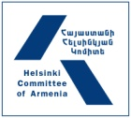

Helsinki Committee of Armenia

 Human Rights Club (Azerbaijan)

 Human Rights House Foundation (Norway)

 Human Rights Monitoring Institute (Lithuania)

 Index on Censorship

 Institute for Reporters’ Freedom and Safety (Azerbaijan)

 International Partnership for Human Rights (Belgium)

 Kazakhstan International Bureau for Human Rights
and Rule of Law
 Lawtrend (Legal Transformation Center – Belarus)

 Moscow Helsinki Group

 Netherlands Helsinki Committee

 Norwegian Helsinki Committee

 Nota Bene (Tajikistan)

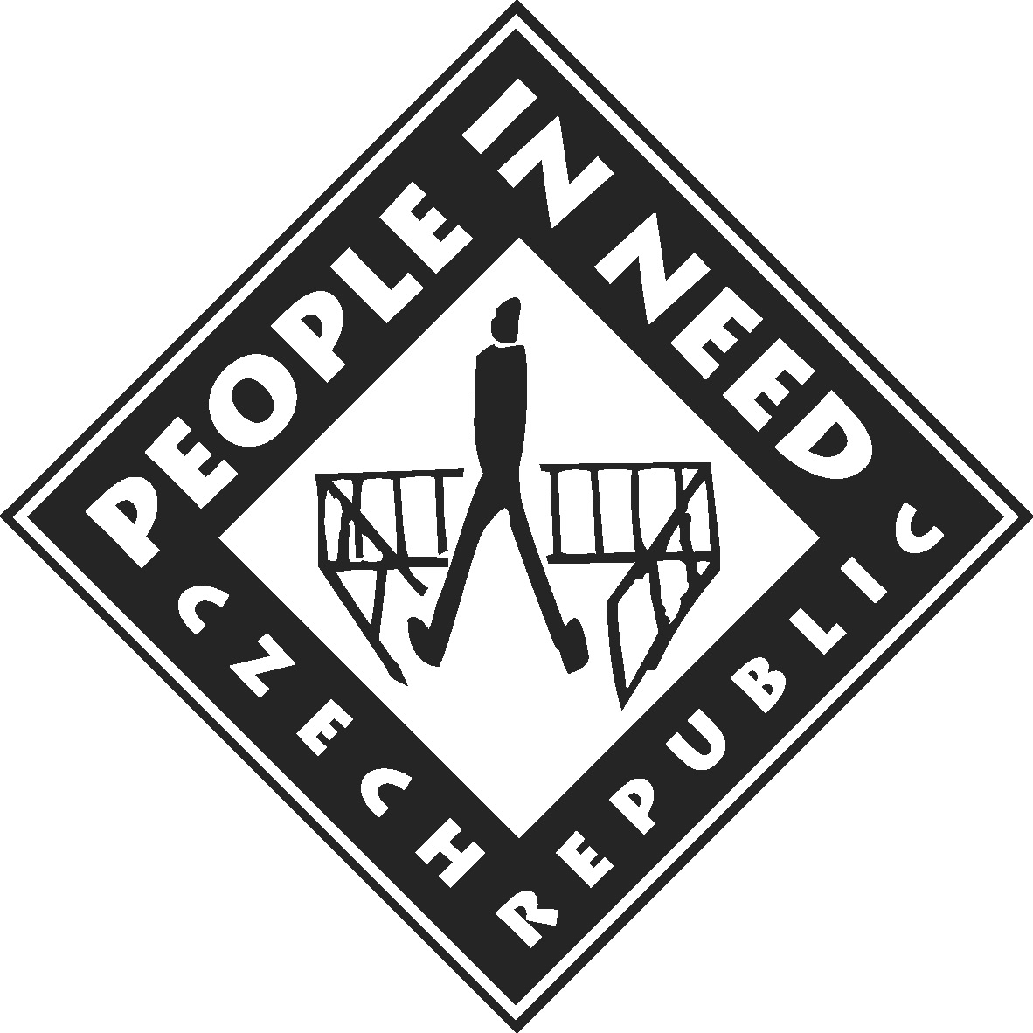 People in Need (Czech Republic)

 Promo LEX Association (Moldova)

 Youth Human Rights Movement (Russia)

